Scenario 1
The remains (fossilised bones) of mammoths and woolly rhinoceros were found heaped at the bottom of a cliff. There were markings on the bones consistent with stone tool markings. Some skulls were cracked open.

Scenario 2
Homo sapiens neanderthalensis incisor teeth show a rounding wearing similar to pattern found in older Inuit (Eskimo) women in the subarctic of North America during the 19th and early 20th centuries. In the Inuit’s case it was usually due to a lifetime of chewing their husbands boots every morning to soften them.
These tools were found as home base sites as well
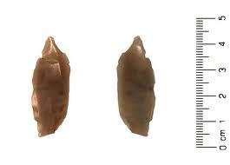

Scenario 6
At one Neanderthal site the fossil remains of a 40-50 year old was found. His bones showed signs of crippling arthritis (which would have make walking difficult) and he only had two teeth left. At another site the buried remains of a 30-45 year old was found who had evidence of crushing injuries from early in life resulting in multiple broken bones. He would have been severely handicapped. The normal life expectancy of a Neanderthal was about 30-35.

Scenario 4
This 400,000 year old structures was found at Terra Amata, France, along with 20 others. They were up to 12m long by 6m wide. Stone tools were also found at the site.
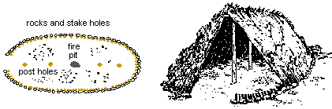

Scenario 5
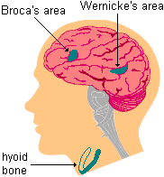
The Neanderthals had a swelling in the brocas and wernicke’s areas as large as our own. The FOXP₂ gene was found in Neanderthals which is related to comprehension. The shape and position of the hyoid bone in Neanderthals is essentially the same as modern humans (this supports muscles in the jaw, tongue and larynx). The mouth and nasal cavity shape is different to modern humans.

Scenario 3
At sites where Neanderthal remains were found there was also charcoal, charred bones and fire altered stone tools found. Some stones showed signs of being repeatedly heated.

Scenario 1
- Hunt
- Drive herds (herd off cliff)
- Cooperate in group hunt
- Butcher animals (tool marks)
- Large community (large kill)
- Remove brains (cracked skulls)
- Use stone tools (tool marks)
Scenario 2
- Work skins/leather
- Make clothes/shelter
- Use tools (borer)
Scenario 3
- Used fire
- Cooked food
- Used stone tools possibly as utensils
- Used fire to alter nature of stone?
- Stone heating plate
Scenario 4
- Made shelter
- Lived in communities
- Used fire
- Made tools
Scenario 5
- Capable of speech
- Comprehend language
- Similar speech capability of modern humans
but probably cant pronounce as wide a range
Scenario 6
- Social structure had developed to a point that community
members unable to look after themselves were fed and cared for.

